

Capstone Project
Report 3
Software Requirements Specifications
(SRS)
Personal Finance Management
Author: PFM Team
Instructor: Mr. Nguyen Van Hien

Hanoi, 7th Sep, 2012

Record of change

*A - Added M - Modified D - Deleted
Effective Date | Changed Items | A*  M, D | Change Description | New Version
Sep 7th, 2012 | Add SRS for Project | A |  | 1.0

Document Approval

The following Software Requirements Specification has been accepted and approved by the following:

Signature | Printed Name | Title | Date
 | Nguyen Anh Tuan | Project manager.
 | Nguyen Van Hien | Instructor.

Table of Contents
1. Introduction 3
1.1. Purpose 3
1.2. Scope 3
1.3. Definitions, Acronyms, and Abbreviations 3
1.4. References 3
1.5. Overview 3
2. Specific Requirements 4
2.1. External Interface Requirements 4
2.1.1. User Interfaces 4
2.1.2. Hardware Interfaces 4
2.1.3. Software Interfaces 4
2.1.4. Communications Interfaces 4
2.2. Functional Requirements 4
2.2.1. Revenue and expenditure management 4
2.2.2. Schedule 5
2.2.3. Borrowing and lending management 5
2.2.4. Report 6
2.2.5. Warning 6
2.2.6. Synchronize 6
2.3. Use Cases 6
2.3.1. Use Case 1: Schedule 6
2.3.2. Use Case 2: Revenue and Expenditure management 18
2.3.3. Use Case 3: Borrowing and Lending money management 29
2.3.4. Use Case 4: Report 42
2.3.5. Use Case 5: Warning 42
2.3.6. Use Case 6: Synchronize 43
2.4. Non-Functional Requirements 43
2.4.2. Reliability 43
2.4.3. Availability 43
2.4.4. Security 43
2.4.5. Maintainability 44
2.4.6. Portability 44
2.5. Logical Database Requirements 44
2.6. Other Requirements 44
3. Entity Relationship Diagram 44
4. Change Management Process 44
A. Appendices. 44
A.1 Message 44
A.2 Appendix 2 44

1. Introduction
The introduction of the Software Requirements Specification (SRS) provides an overview of the entire SRS. It includes the purpose, scope, definitions, acronyms, abbreviations, references, and overview of the SRS.

Purpose
This SRS document describes functional and nonfunctional requirements for the Money Tracker, helps user manage personal finance. This document is intended to be used by the members of the project team that will implement and verify the correct functioning of the system.

Scope
The product that will be developed is a Money Tracker. This product uses both hardware, software, and many technologies to support the task at hand.
It is application for android and using NFC technology.

Definitions, Acronyms, and Abbreviations

Abbreviations | Description | Note
PFM | Personal Finance Management
PM | Project Manager
NFC | Near Field Communication
TP | Test Plan
TC | Test Case
TR | Test Report
UT | Unit test
SRS | Software Requirements Specification
MSG | Message

References

Overview
This document contains the complete description of the behavior of Personal Finance Management application and includes a set of use cases that describe interactions the users will have with the software. In addition it also contains non-functional requirements. Non-functional requirements impose constraints on the design or implementation (such as performance engineering requirements, quality standards, or design constraints).

Specific Requirements
This section of the SRS contains all software requirements to a level of detail sufficient to enable designers to design a system to satisfy those requirements, and testers to test that the system satisfies those requirements. When using use-case modeling, these requirements are captured in the Use Cases and the applicable supplementary specifications. If use-case modeling is not used, the outline for supplementary specifications may be inserted directly into this section, as shown below.

External Interface Requirements

User Interfaces
- Application’s interfaces need to be clear and easy to use.
- Show message to confirm user in necessary cases.
- Display alert if user makes an error.
- Charts are clear and easy to understand.

Hardware Interfaces
- Google devices that support Android OS.
- NFC tags.
- Server.

Software Interfaces
- Java Development Kit (required for Android deployment).
- Android SDK (required for Android deployment).
- Eclipse (required for development environment).
- SQLite.
- Windows server.

Communications Interfaces

Functional Requirements
This section describes specific features of the software project. If desired, some requirements may be specified in the use-case format and listed in the Use Cases Section.

Revenue and expenditure management
This is the main and most important function of the system. It helps user manage revenue and expenditure every month. This function allows the user to input the income / expenses in every day and then save the data.
- Input expenses:
- The program will provide a default list of expenditures for user selected to input data (“Ăn uống”, “Điện”, “Nước”, “Sinh nhật”, “Tiệc tùng”, “Nhà”…)
- If expenses are not included in the list, the user can create a new account by selecting the "Khác". When select this option, immediately below will appear second textbox allows the user to manually enter other expenses. Then the program will automatically update the list to user do not have to re-enter when need enter a similar cost.
- After user saves one new expense in the day, at the bottom of the screen will display information:
- The total cost was used
- The remaining amount
- Use the QR code to input data
- Use NFC to input data
- Input revenue: Users can manipulate the same with expenses.

Schedule
This function helps user plan expenditure every month/week.
- The system will default time to start is the current date, in addition
the user also can manually enter start date.
- Next is total money user will expense in month/week (include total budget and detail budget)
- The user can enter a total budget, or just enter detailed budget.
- When the user does not enter a total budget, just enter the details budget,
system will automatically update the total budget.
- With detailed budget system will support a list of expenditures
(“Ăn uống”, “Điện”, “Nước”, “Sinh nhật”, “Tiệc tùng”, “Nhà”…) to user select. With one expenses not included in the list, the user can
select the "Khác" and create one new detail budget. And then system will save
and update it on the list available.
- If a user enters the detailed budget and total budget, when total of details budget greater total budget, the system will alert by displaying message with two options:
- Automatically update the total budget to match the detailed budget.
- Allow user update total budget or edit detail budget to accord.

Borrowing and lending management
This function allows the user to easily manage borrowing and lending.
With account payables or account receivables, the user will enter the necessary information such as:
- Total money (borrowing, lending or saving)
- Name (the lender, the borrower or where saving)
- Phone numbers and addresses.
- Term (borrowing, lending, saving).
- This type of interest rate.
- Interest (only support a fixed rate).
- In the case “Name” has in the contacts of mobile, the system will retrieve the information such as phone number and address of this person and user will not have to manually enter.
- User can view details borrowing, lending or saving, and interest received each day.
- When view, the system will sort accounts follow maturity closest.

Report
This function helps user has an overview of the expenses in a month, compare with plan or other month.
Beside detail report income and expense in the form of small reports, system also has some charts such as pie chart, growth charts to help user analyses and understand about their revenues and expenditures of the week, months and between the weeks and months.

Warning
This function uses to reminder users about expenditures, borrowing, lending and saving.
- When expenditures exceed plan.
- When the maturity of borrowing or lending.

Synchronize
This function will ensure the safety data for user, and support the users use multiple devices.
Data created by user will be stored in the device, when a network connection, data will be synchronized with the server. And in other devices, if a network connection, this data
will also be updated from the server.

Use Cases

Use Case 1: Schedule
- Use-case Diagram
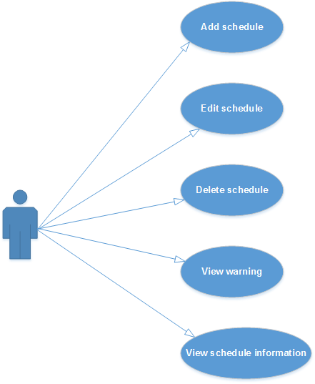
Figure 1: Schedule use-case diagram
- Use-case Specification

USE CASE- Create Schedule SPECIFICATION

Use-case No. | UC SC.1 | Use-case Version |  | 1.0
Use-case Name | Create Schedule
Author | LinhLLL
Date | 08/09/2012 | Priority | High
Actor:
User
Summary:
User can create budget, detail expense for current week or month.
Goal:
Allow user create budget and plan schedule.
Triggers
Touch “Schedule” tab.
Preconditions:
Accessed to application
Post Conditions:
<List the required post-conditions for using this case>
Main Success Scenario:

Step | Actor action | System response
1 | Touch “Kế hoạch” tab | Display “Tháng” screen
2 | Touch create icon at the top- right concern of screen | Display create screen
3 | Touch “Tháng” toggle | Change toggle “Tháng” to “Tuần”
4 | Enter data into “Tổng ngân sách” field | Display entered data
5 | Touch save icon at the top- right concern of screen | - Return “Tháng” screen  - Show message “Saved”  - Display saved
ata
Step | Actor action | System response
1 | Touch second icon at the bottom of screen | Display “Tháng” screen
2 | Touch create icon at the top- right concern of screen | Display create screen
3 | Enter data into all fields | Display all entered data
4 | Touch cancel icon beside save icon | - Return “Tháng” screen

Alternative Scenario:

Step | Actor action | System response
1 | Touch “Kế hoạch” tab | Display “Tháng” screen
2 | Touch create icon at the top- right concern of screen | Display create screen
3 | Enter data into “Ăn uống” field on screen | Display entered data
4 | Touch plus icon beside “Ăn uống” field | Display:  - Default combobox is: “Ăn uống”  - One field
5 | Touch combobox “Ăn uống” | Display list options:  - Điện  - Nước  - Nhà  - Sinh nhật  - Tiệc tùng  - Khác
6 | Choose “Điện” option | Display combobox value is “Điện”
7 | Enter data into new field | Display entered data
8 | Touch save icon at the top- right concern of screen | - Return “Tháng” screen  - Show message “Saved”  - Display saved data

Step | Actor action | System response
1 | Touch second icon at the bottom of screen | Display “Tháng” screen
2 | Touch create icon at the top- right concern of screen | Display create screen
3 | Touch first date field | Choose desired time
4 | Enter data into “Tổng ngân sách” field | Display entered data
5 | Touch save icon | - Return “Tháng” screen  - Show message “Saved”  - Display saved data

Exceptions:

Step | Actor action | System response
1 | Touch second icon at the bottom of screen | Display “Tháng” screen
2 | Touch create icon at the top- right concern of screen | Display create screen
3 | Touch first date field | Choose desired time
4 | Enter data into “Tổng ngân sách” field | Display entered data
5 | Enter data into “Ăn uống” field on screen | Display entered data
6 | Touch plus icon beside “Ăn uống” field | Display:  - Default combobox is: “Ăn uống”  - One field
7 | Enter data into new field | Display entered data
5 | Touch save icon | If total of detail budget greater than “Tổng ngân sách” display:  - Message: “Tổng chi phí của bạn đã vượt quá ngân sách đề ra, bạn muốn tăng thêm ngân sách không?”  - 2 buttons: “Có” and “Không”

Relationships:
UC 002.2, UC 002.3, UC 002.4
Business Rules:

No | Rule Description
1 | In order to create new schedule, user must accessed application
2 | In order to save schedule, user must enter data into mandatory field

Screen:
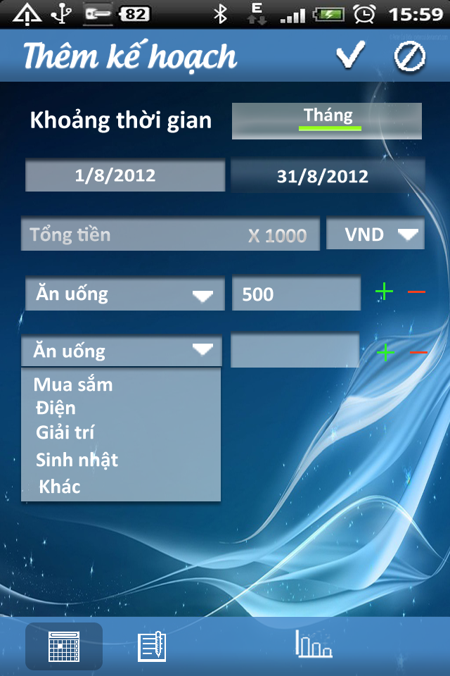

USE CASE- Edit Schedule SPECIFICATION

Use-case No. | UC SC.2 | Use-case Version |  | 1.0
Use-case Name | Edit Schedule
Author | LinhLLL
Date | 08/09/2012 | Priority | High
Actor:
User
Summary:
User can edit monthly or weekly budget, detail expense for user’s schedule which they created.
Goal:
Allow user edit budget and plan schedule.
Triggers
Touch “Schedule” tab.
Preconditions:
Accessed to application
Post Conditions:
<List the required post-conditions for using this case>
Main Success Scenario:

Step | Actor action | System response
1 | Touch second icon at the bottom of screen | Display “Kế hoạch” screen
2 | Choose one schedule in list schedule on screen | Display detail information of schedule
3 | Touch edit icon at the top- right of screen | Display edit screen
4 | Edit data in all fields | All data is changed
5 | Touch save icon at the top- right of screen | - Return “Tháng” screen  - Show message “Saved”  - Display saved data

Step | Actor action | System response
1 | Touch second icon at the bottom of screen | Display “Kế hoạch” screen
2 | Choose one schedule in list schedule on screen | Display detail information of schedule
3 | Touch edit icon at the top- right of screen | Display edit screen
4 | Edit data in all fields | All data is changed
5 | Touch cancel icon beside save icon | - Return “Tháng” screen  - No data is edited

Alternative Scenario:
Exceptions:

Step | Actor action | System response
1 | Touch second icon at the bottom of screen | Display “Kế hoạch” screen
2 | Choose one schedule in list schedule on screen | Display detail information of schedule
3 | Touch edit icon at the top- right of screen | Display edit screen
4 | Edit data in all fields | All data is changed
5 | Touch save icon at the top- right of screen | If total of detail budget greater than “Tổng ngân sách” display:  - Message: “Tổng chi phí của bạn đã vượt quá ngân sách đề ra, bạn muốn tăng thêm ngân sách không?”  - 2 buttons: “Có” and “Không”

Step | Actor action | System response
1 | Touch second icon at the bottom of screen | Display “Tháng” screen
2 | Touch create icon at the top- right concern of screen | Display create screen
3 | Touch first date field | - Choose desired time  - If desired time coincides with available time, show:  + Message: “Thời gian này đã có lịch! Xin vui lòng chọn lại!”

Relationships:
UC SC.1, UC SC.4
Business Rules:

No | Rule Description
1 | In order to edit schedule, user must accessed application
2 | In order to edit schedule, “Kế hoạch” screen must have at least one schedule
3 | In order to save schedule, user must enter data into at least one field

Screen:
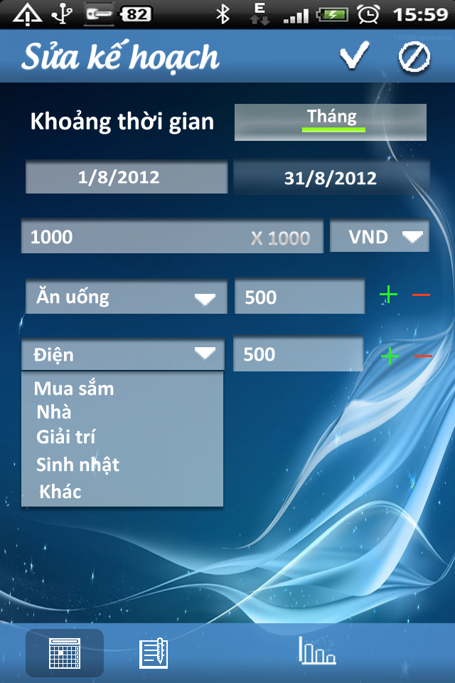

USE CASE- Delete Schedule SPECIFICATION

Use-case No. | UC SC.3 | Use-case Version |  | 1.0
Use-case Name | Delete Schedule
Author | LinhLLL
Date | 08/09/2012 | Priority | High
Actor:
User
Summary:
User can delete schedule.
Goal:
Allow user delete schedule.
Triggers
Touch “Schedule” tab.
Preconditions:
Accessed to application
Post Conditions:
<List the required post-conditions for using this case>
Main Success Scenario:

Step | Actor action | System response
1 | Touch second icon at the bottom of screen | Display “Tháng” screen
2 | Long click on one schedule in list schedule | Display menu includes:  - “Thêm mới”  - “Chỉnh sửa”  - “Xóa”
3 | Touch “Xóa” | Show pop-up confirm includes:  - Message: “Bạn muốn xóa kế hoạch này không?”  - 2 buttons: “Có” and “Không”
4 | Touch “Có” button | - Clear schedule  - Show message: “Đã xóa”

Step | Actor action | System response
1 | Touch “Schedule” tab | Display “Tháng” screen
2 | Long click on one schedule | Display menu includes:  - Thêm mới  - Chỉnh sửa  - Xóa
3 | Touch “Xóa” | Show pop-up confirm includes:  - Message: “Bạn muốn xóa kế hoạch này không?”  - 2 buttons: “Có” and “Không”
4 | Touch “Không” button | - Return “Tháng” screen

Alternative Scenario:
Exceptions:
Relationships:
UC SC.1, UC SC.2, UC SC.4
Business Rules:

No | Rule Description
1 | In order to delete schedule, user must accessed application
2 | In order to delete schedule, “Schedule” screen must have at least one schedule

Screen:
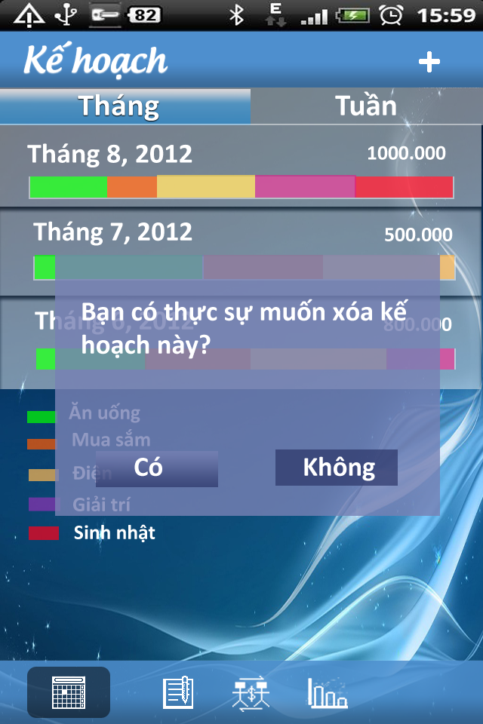

USE CASE- View Schedule SPECIFICATION

Use-case No. | UC SC.4 | Use-case Version |  | 1.0
Use-case Name | View Schedule
Author | LinhLLL
Date | 08/09/2012 | Priority | High
Actor:
User
Summary:
User can view list of schedule or schedule detail.
Goal:
Allow user view schedule.
Triggers
Touch “Schedule” tab.
Preconditions:
Accessed to application
Post Conditions:
<List the required post-conditions for using this case>
Main Success Scenario:

Step | Actor action | System response
1 | Touch second icon at the bottom of screen | Display “Tháng” screen include list of monthly schedule  - Each schedule includes information below:  + Total budget  + Time  + Chart descripts this schedule
2 | Touch “Tuần” tab | Display “Tuần” screen include list of monthly schedule  - Each schedule includes information below:  + Total budget  + Time  + Chart descripts this schedule”

Step | Actor action | System response
1 | Touch “Schedule” tab | Display “Tháng” screen
2 | Touch one schedule in list of schedule | Display “Chi tiết” screen includes all information below:  - Schedule time  - List items of living cost  - Amount of money is used for each item  - Simple report

Alternative Scenario:

Step | Actor action | System response
1 | Touch second icon at the bottom of screen | Display “Tháng” screen with content “Không có dữ liệu”
2 | Touch “Tuần” tab | Display “Tháng” screen with content “Không có dữ liệu”

Step | Actor action | System response
1 | Touch second icon at the bottom of screen | Display “Tháng” screen with content “Không có dữ liệu”
2 | Touch “Tuần” tab | Display “Tuần” screen include list of monthly schedule  - Each schedule includes information below:  + Total budget  + Time  + Chart descripts this schedule”

Step | Actor action | System response
1 | Touch second icon at the bottom of screen | Display “Tháng” screen include list of monthly schedule  - Each schedule includes information below:  + Total budget  + Time  + Chart descripts this schedule
2 | Touch “Tuần” tab | Display “Tuần” screen with content “Không có dữ liệu”

Exceptions:
Relationships:
UC SC.1, UC SC.2, UC SC.3
Business Rules:

No | Rule Description
1 | In order to delete schedule, user must accessed application
2 | In order to delete schedule, “Schedule” screen must have a
l
Screen:
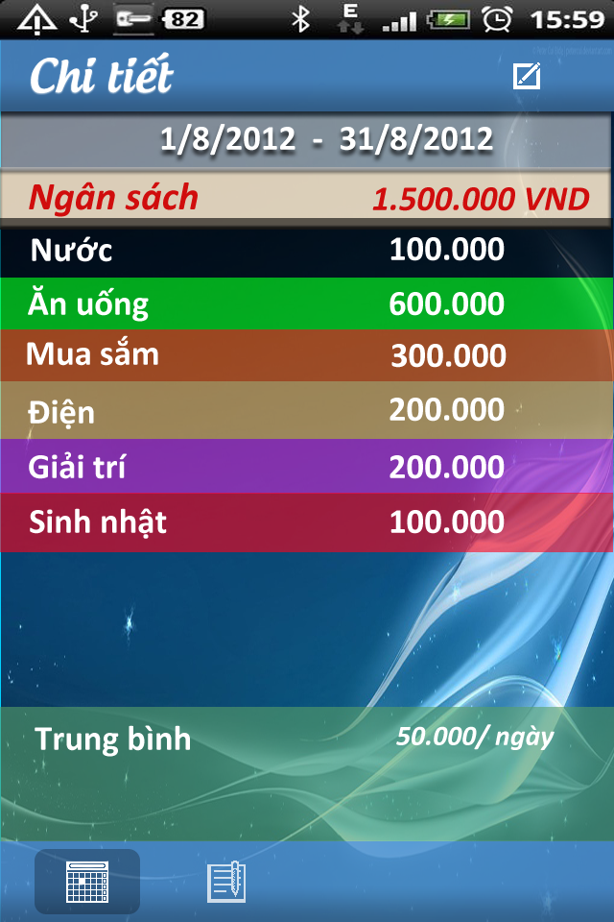
ast one schedule

Use Case 2: Revenue and Expenditure management
- Use-case Diagram
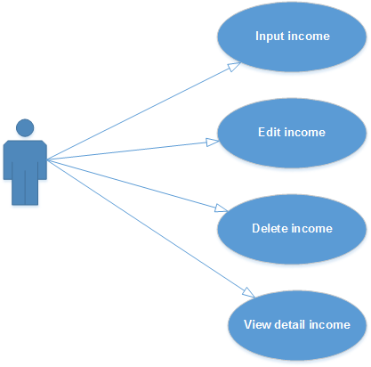
Figure 2: Income management use-case diagram
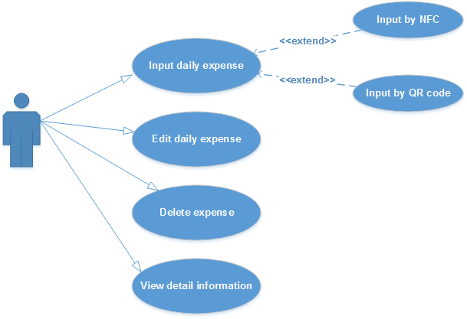
Figure 3: Expense management use-case diagram

- Use-case Specification
USE CASE- View Expense SPECIFICATION

Use-case No. | UC001.1 | Use-case Version |  | 1.0
Use-case Name | View Expense
Author | LinhLLL
Date | 03/10/2012 | Priority | High
Actor:
User
Summary:
User can view monthly expense or daily expense.
Goal:
Allow user view detail expense.
Triggers
Touch management icon, first icon at the bottom of screen.
Preconditions:
Accessed to application
Post Conditions:
<List the required post-conditions for using this case>

Main Success Scenario:

Step | Actor action | System response
1 | Touch first icon at the bottom of screen | Display “Chi phí” screen includes:  - List of expense  - Add new expense icon at the top-right of screen
2 | Touch one item of list | Display sub- item of selected item
3 | Touch one sub-item | Display “Chi phí ngày” screen

Alternative Scenario:
Step | Actor action | System response
1 | Touch first icon at the bottom of screen | Display “Chi phí” screen includes:  - List of expense  - Add new expense icon at the top-right of screen
2 | Touch “Thu nhập” tab | Display “Thu nhập” screen

Step | Actor action | System response
1 | Touch first icon at the bottom of screen | Display “Chi phí” screen with content “No data”
2 | Touch “Thu nhập” tab | Display “Thu nhập” screen with content “No data”

Exceptions: N/A
Relationships:
UC 002.2, UC 002.3, UC 002.4
Business Rules:

No | Rule Description
1 | In order to view expense, user must accessed application
2 | In order to view detail, user must touch one item of list expense
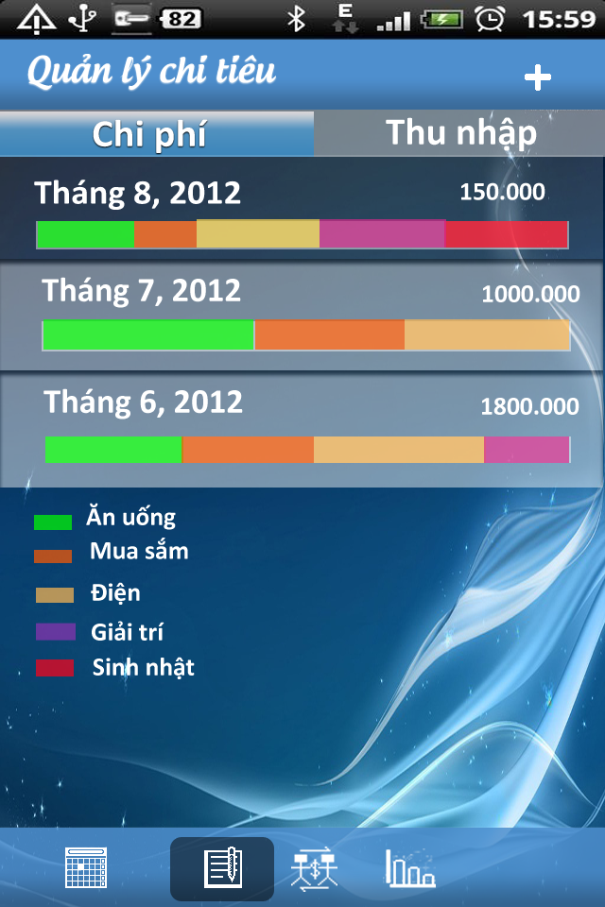
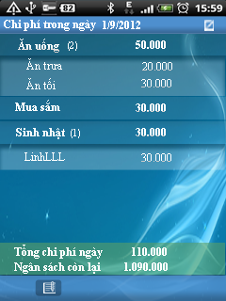
Screen:

USE CASE- Add Daily Expense or Income SPECIFICATION

Use-case No. | UC001.1 | Use-case Version |  | 1.0
Use-case Name | Add Daily Expense or Income
Author | LinhLLL
Date | 03/10/2012 | Priority | High
Actor:
User
Summary:
User can input daily expense.
Goal:
Allow user input detail expense.
Triggers
Touch management icon, first icon at the bottom of screen.
Preconditions:
Accessed to application
Post Conditions:
<List the required post-conditions for using this case>

Main Success Scenario:

Step | Actor action | System response
1 | Touch first icon at the bottom of screen | Display “Chi phí” screen
2 | Touch add new icon at the top- right concern of screen | Display “Thêm chi phí” screen
3 | Enter data into all fields | Display all entered data
4 | Touch save icon at the top- right concern of screen | - Return “Chi phí” screen  - Show message “Saved”  - Display saved data

Step | Actor action | System response
1 | Touch first icon at the bottom of screen | Display “Chi phí” screen
2 | Touch add new icon at the top- right concern of screen | Display “Thêm chi phí” screen
3 | Enter data into all fields | Display all entered data
4 | Touch cancel icon besides save icon | - Return “Chi phí” screen  - Nothing is saved

Alternative Scenario:

Step | Actor action | System response
1 | Touch first icon at the bottom of screen | Display “Chi phí” screen
2 | Touch add new icon at the top- right concern of screen | Display “Thêm chi phí” screen
3 | Touch “Chi phí” toggle | Change “Chi phí” to “Thu nhập”
4 | Enter data into all fields | Display all entered data
5 | Touch save icon at the top- right concern of screen | - Return “Chi phí” screen  - Show message “Saved”  - Display saved data

Step | Actor action | System response
1 | Touch first icon at the bottom of screen | Display “Chi phí” screen
2 | Touch add new icon at the top- right concern of screen | Display “Thêm chi phí” screen
3 | Touch first date field | Choose desired time
4 | Enter data into all remaining field | Display entered data
5 | Touch save icon | - Return “Chi phí” screen  - Show message “Saved”  - Display saved data

Exceptions:

Step | Actor action | System response
1 | Touch first icon at the bottom of screen | Display “Chi phí” screen
2 | Touch create icon at the top- right concern of screen | Display “Thêm chi phí ” screen
3 | Touch first date field | Choose desired time
4 | Enter data into all field | Display entered data  - If amount of money make total expense greater than budget:  + show message: “Chi phí này vượt quá ngân sách của bạn. Bạn muốn tăng thêm ngân sách không?”  + 2 buttons: “Có” and “Không”
5 | Touch “Có” | - Update budget and expense  - Show message: “Đã tăng ngân sách”
6 | Touch save icon | - Return “Chi phí” screen  - Show message “Saved”  - Display saved data

Relationships:
UC 001.1, UC 001.3, UC 001.4
Business Rules:

No | Rule Description
1 | In order to add new daily expense, user must accessed application
2 | In order to save expense, user must enter data into mandatory field
Screen:
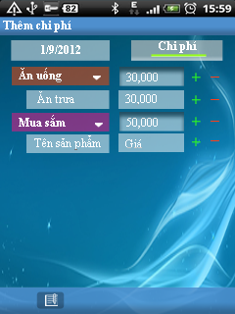

USE CASE- Edit Expense or Income SPECIFICATION

Use-case No. | UC001.3 | Use-case Version |  | 1.0
Use-case Name | Edit expense or income
Author | LinhLLL
Date | 03/10/2012 | Priority | High
Actor:
User
Summary:
User can edit detail expense which they added.
Goal:
Allow user edit expense.
Triggers
Touch first icon at the bottom of screen
Preconditions:
Accessed to application
Post Conditions:
<List the required post-conditions for using this case>
Main Success Scenario:

Step | Actor action | System response
1 | Touch first icon at the bottom of screen | Display “Chi phí” screen includes list of expense
2 | Choose one item of list expense on screen | Display view detail screen
3 | Touch edit icon at the top- right of screen | Display edit screen
4 | Edit data in all fields | All data is changed
5 | Touch save icon at the top- right of screen | - Return view detail screen  - Show message “Saved”  - Display saved data

Step | Actor action | System response
1 | Touch first icon at the bottom of screen | Display “Chi phí” screen
2 | Choose one item of list expense on screen | Display view detail screen
3 | Touch edit icon at the top- right of screen | Display edit screen
4 | Edit data in all fields | All data is changed
5 | Touch cancel icon beside save icon | - Return view detail screen  - No data is edited

Alternative Scenario:

Step | Actor action | System response
1 | Touch first icon at the bottom of screen | Display “Chi phí” screen includes list of expense
2 | Choose one item of list expense on screen | Display view detail screen includes detail information of expense
3 | Touch edit icon at the top- right of screen | Display edit screen
4 | - Touch “Chi phí” toggle  - Edit data in all fields | - Change “Chi phí” to “Thu nhập” toggle  - All data is changed
5 | Touch save icon at the top- right of screen | - Return view detail screen  - Show message “Saved”  - Display saved data

Exceptions: N/A
Relationships:
UC 001.1,UC 001.2, UC 001.4
Business Rules:

No | Rule Description
1 | In order to edit expense/income, user must accessed application
2 | In order to edit expense/income, “Chi phí”/ “Thu nhập” screen must have at least one schedule
3 | In order to save what user edited, user must enter data into mandatory field

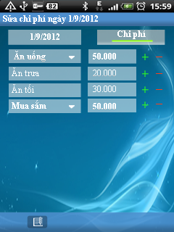
Screen:

USE CASE- Delete Expense or Income SPECIFICATION

Use-case No. | UC001.4 | Use-case Version |  | 1.0
Use-case Name | Delete expense or income
Author | LinhLLL
Date | 03/10/2012 | Priority | High
Actor:
User
Summary:
User can delete expense or income.
Goal:
Allow user delete expense or income.
Triggers
Touch first icon at the bottom of screen.
Preconditions:
Accessed to application
Post Conditions:
<List the required post-conditions for using this case>
Main Success Scenario:

Step | Actor action | System response
1 | Touch first icon at the bottom of screen | Display “Chi phí” screen
2 | Long click on one item in list expense | Display menu includes:  - “Thêm mới”  - “Chỉnh sửa”  - “Xóa”
3 | Touch “Xóa” | Show pop-up confirm includes:  - Message: “Bạn muốn xóa khoản chi này không?”  - 2 buttons: “Có” and “Không”
4 | Touch “Có” button | - Clear expense  - Show message: “Đã xóa”

Step | Actor action | System response
1 | Touch “Schedule” tab | Display “Chi phí” screen
2 | Long click on one schedule | Display menu includes:  - Thêm mới  - Chỉnh sửa  - Xóa
3 | Touch “Xóa” | Show pop-up confirm includes:  - Message: “Bạn muốn xóa khoản chi này không?”  - 2 buttons: “Có” and “Không”
4 | Touch “Không” button | - Return “Chi phí” screen

Alternative Scenario:

Step | Actor action | System response
1 | Touch first icon at the bottom of screen | Display “Chi phí” screen
2 | Touch “Thu nhập” tab | Display “Thu nhập” screen
3 | Long click on one item in list income | Display menu includes:  - “Thêm mới”  - “Chỉnh sửa”  - “Xóa”
4 | Touch “Xóa” | Show pop-up confirm includes:  - Message: “Bạn muốn xóa khoản thu này không?”  - 2 buttons: “Có” and “Không”
5 | Touch “Có” button | - Clear income  - Show message: “Đã xóa”

Exceptions:
Relationships:
UC 001.1, UC 001.2, UC 001.3
Business Rules:

No | Rule Description
1 | In order to delete schedule, user must accessed application
2 | In order to delete schedule, “Schedule” screen must have at least one schedule

Screen:

Use Case 3: Borrowing and Lending money management
- Use-case Diagram

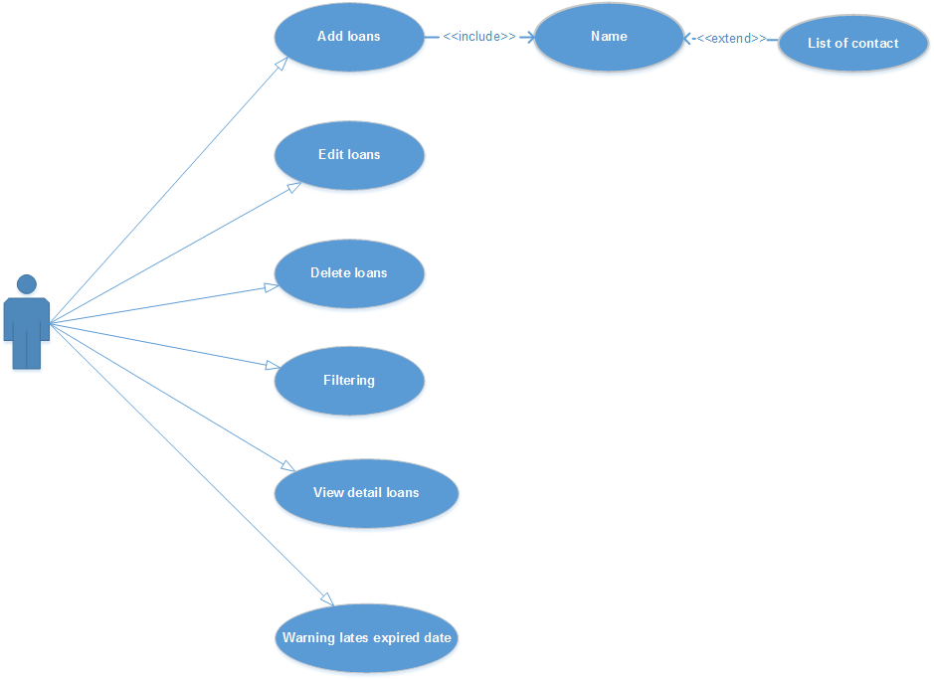

Figure 3: Borrowing and Lending money management use-case diagram

- Use-case Specification

USE CASE- Add New Loans SPECIFICATION

Use-case No. | UC BL.1 | Use-case Version |  | 1.0
Use-case Name | Add New Loans
Author | LinhLLL
Date | 08/09/2012 | Priority | High
Actor:
User
Summary:
User can add new loan.
Goal:
Allow user input detail information of loan.
Triggers
Touch “Vay nợ” tab, thirst icon at the bottom of screen.
Preconditions:
Accessed to application
Post Conditions:
<List the required post-conditions for using this case>
Main Success Scenario:

Step | Actor action | System response
1 | Touch “Vay nợ” tab, thirst icon at the bottom of screen | Display “Vay” tab includes list of borrowing money
2 | Touch create icon at the top- right of screen | Display create screen
3 | Enter data into mandatory fields | Display all entered data  - If entered name is not available in mobile contact, display pop-up to add new contact
4 | Touch save icon at the top- right of screen | - Return “Vay” screen  - Show message: “Saved”  - Display all saved data

Step | Actor action | System response
1 | Touch “Vay nợ” tab, thirst icon at the bottom of screen | Display “Vay” tab includes list of borrowing money
2 | Touch create icon at the top- right of screen | Display create screen
3 | Enter data into mandatory fields | Display all entered data
4 | Touch cancel icon besides save icon | - Return “Vay” screen  - Nothing is added

Alternative Scenario:

Step | Actor action | System response
1 | Touch “Vay nợ” tab, thirst icon at the bottom of screen | Display “Vay” tab includes list of borrowing money
2 | Touch create icon at the top- right of screen | Display create screen
3 | Touch “Kiểu” toggle | Change “Vay” to “Cho vay”
4 | Enter data into all fields | Display all entered data  - If entered name is available in mobile contact, system can be automatic display phone number and address
5 | Touch save icon at the top- right of screen | - Return “Vay” screen  - Show message: “Saved”  - Display all saved data

Exceptions:

Step | Actor action | System response
1 | Touch “Vay nợ” tab, thirst icon at the bottom of screen | Display “Vay” tab includes list of borrowing money
2 | Touch create icon at the top- right of screen | Display create screen
3 | Touch “Kiểu” toggle | Change “Vay” to “Cho vay”
4 | Enter data into all fields except “Ngày bắt đầu” và “Ngày đáo hạn” field | Display all entered data  - If entered name is available in mobile contact, system can be automatic display phone number and address
5 | Touch save icon at the top- right of screen | - Show message: “Bạn phải nhập ngày đáo hạn!”  - Return create screen

Step | Actor action | System response
1 | Touch “Vay nợ” tab, thirst icon at the bottom of screen | Display “Vay” tab includes list of borrowing money
2 | Touch create icon at the top- right of screen | Display create screen
3 | Touch “Kiểu” toggle | Change “Vay” to “Cho vay”
4 | Enter data into all fields except “Lãi suất” và “Ngày đáo hạn” field | Display all entered data  - If entered name is available in mobile contact, system can be automatic display phone number and address
5 | Touch save icon at the top- right of screen | - Return “Vay” screen  - Show message: “Saved”  - Display all saved data

Relationships:
Business Rules:

No | Rule Description
1 | In order to add borrowing money, user must accessed application
2 | In order to save data, user must enter data into mandatory field

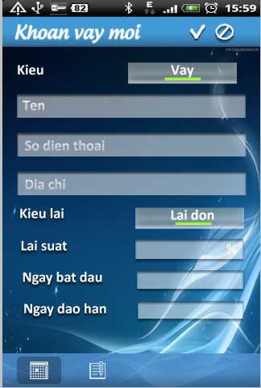
Screen:

USE CASE- Edit Loans SPECIFICATION

Use-case No. | UC BL.2 | Use-case Version |  | 1.0
Use-case Name | Edit Loans
Author | LinhLLL
Date | 08/09/2012 | Priority | High
Actor:
User
Summary:
User can edit information of loan.
Goal:
Allow user edit detail information of loan.
Triggers
Touch “Vay nợ” tab, thirst icon at the bottom of screen.
Preconditions:
Accessed to application
Post Conditions:
<List the required post-conditions for using this case>
Main Success Scenario:

Step | Actor action | System response
1 | Touch “Vay nợ” tab, thirst icon at the bottom of screen | Display “Vay” tab includes list of borrowing money
2 | Choose one borrowing money in list of borrowing money | Display detail information screen
3 | Touch edit icon at the top- right of screen | Display edit screen
4 | Change all of data in fields | Display all data is changed
5 | Touch save icon at the top- right of screen | - Return “Vay” screen  - Show message: “Saved”  - Display all saved data

Step | Actor action | System response
1 | Touch “Vay nợ” tab, thirst icon at the bottom of screen | Display “Vay” tab includes list of borrowing money
2 | Choose one borrowing money in list of borrowing money | Display detail information screen
3 | Touch edit icon at the top- right of screen | Display edit screen
4 | Change all of | data in fields  Display all data is changed
5 | Touch cancel icon besides save icon | - Return “Vay” screen  - Nothing is changed

Alternative Scenario:

Step | Actor action | System response
1 | Touch “Vay nợ” tab, thirst icon at the bottom of screen | Display “Vay” tab includes list of borrowing money
2 | Choose one borrowing money in list of borrowing money | Display detail information screen
3 | Touch edit icon at the top- right of screen | Display edit screen
4 | Touch “Kiểu” toggle | Change “Vay” to “Cho vay”
5 | Change data in all fields | Display all changed data
6 | Touch save icon at the top- right of screen | - Return “Vay” screen  - Show message: “Saved”  - Display all saved data

Step | Actor action | System response
1 | Touch “Vay nợ” tab, thirst icon at the bottom of screen | Display “Vay” tab includes list of borrowing money
2 | Choose one borrowing money in list of borrowing money | Display detail information screen
3 | Touch edit icon at the top- right of screen | Display edit screen
4 | Clear data in “Lãi suất” field | “Lãi suất” is empty field
5 | Clear data in “Ngày đáo hạn” | “Ngày đáo hạn” is empty field
6 | Touch save icon at the top- right of screen | - Return “Vay” screen  - Show message: “Saved”  - Display all saved data

Exceptions:

Step | Actor action | System response
1 | Touch “Vay nợ” tab, thirst icon at the bottom of screen | Display “Vay” tab includes list of borrowing money
2 | Touch create icon at the top- right of screen | Display create screen
3 | Touch “Kiểu” toggle | Change “Vay” to “Cho vay”
4 | Clear data in one of field below:  - “Tên”  - “Tổng tiền”  - “Ngày bắt đầu”  - “Ngày kết thúc” | Display all empty field
5 | Touch save icon at the top- right of screen | - Display message: “Xin hãy nhập dữ liệu vào các ô đang bị bỏ trống! Xin cảm ơn!”

Step | Actor action | System response
1 | Touch “Vay nợ” tab, thirst icon at the bottom of screen | Display “Vay” tab includes list of borrowing money
2 | Choose one borrowing money in list of borrowing money | Display detail information screen
3 | Touch edit icon at the top- right of screen | Display edit screen
5 | Clear data in “Ngày đáo hạn” | “Ngày đáo hạn” is empty field
6 | Touch save icon at the top- right of screen | - Show message: “Để tính được lãi suất bạn phải nhập vào ngày đáo hạn!”

Relationships:
UC BL.1, UC BL.4
Business Rules:

No | Rule Description
1 | In order to add borrowing money, user must accessed application
2 | In order to save data, user must enter data into mandatory field

Screen:
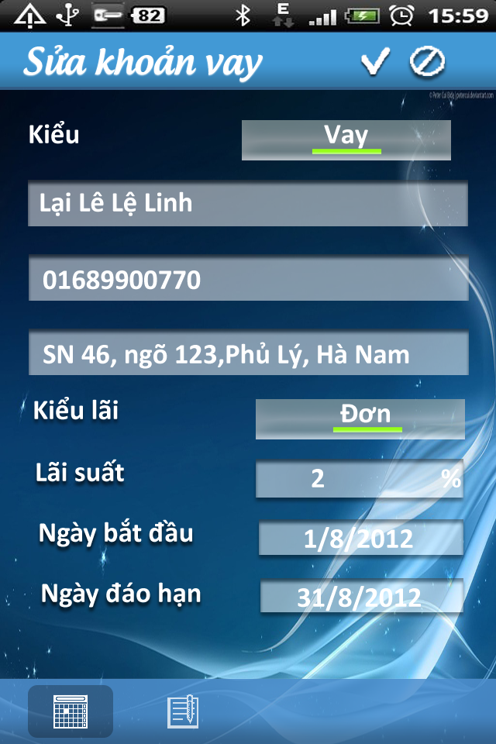

USE CASE- Delete Loans SPECIFICATION

Use-case No. | UC BL.3 | Use-case Version |  | 1.0
Use-case Name | Delete Loans
Author | LinhLLL
Date | 08/09/2012 | Priority | High
Actor:
User
Summary:
User can delete loan.
Goal:
Allow user delete loan.
Triggers
Touch “Vay nợ” tab, thirst icon at the bottom of screen.
Preconditions:
Accessed to application
Post Conditions:
<List the required post-conditions for using this case>
Main Success Scenario:

Step | Actor action | System response
1 | Touch “Vay nợ” tab, thirst icon at the bottom of screen | Display “Vay” tab includes list of borrowing money
2 | Long click on one borrowing in list borrowing | Display menu includes:  - “Thêm mới”  - “Chỉnh sửa”  - “Xóa”
3 | Touch “Xóa” | Show pop-up confirm includes:  - Message: “Bạn muốn xóa kế hoạch này không?”  - 2 buttons: “Có” and “Không”
4 | Touch “Có” button | - Clear borrowing  - Show message: “Đã xóa”

Step | Actor action | System response
1 | Touch “Vay nợ” tab, thirst icon at the bottom of screen | Display “Vay” tab includes list of borrowing money
2 | Long click on one borrowing in list borrowing | Display menu includes:  - “Thêm mới”  - “Chỉnh sửa”  - “Xóa”
3 | Touch “Xóa” | Show pop-up confirm includes:  - Message: “Bạn muốn xóa kế hoạch này không?”  - 2 buttons: “Có” and “Không”
4 | Touch “Không” button | - Return “Vay” screen

Alternative Scenario:
Exceptions:
Relationships:
UC BL.1, UC BL.2
Business Rules:

No | Rule Description
1 | In order to add borrowing money, user must accessed application
2 | In order to save data, user must enter data into mandatory field

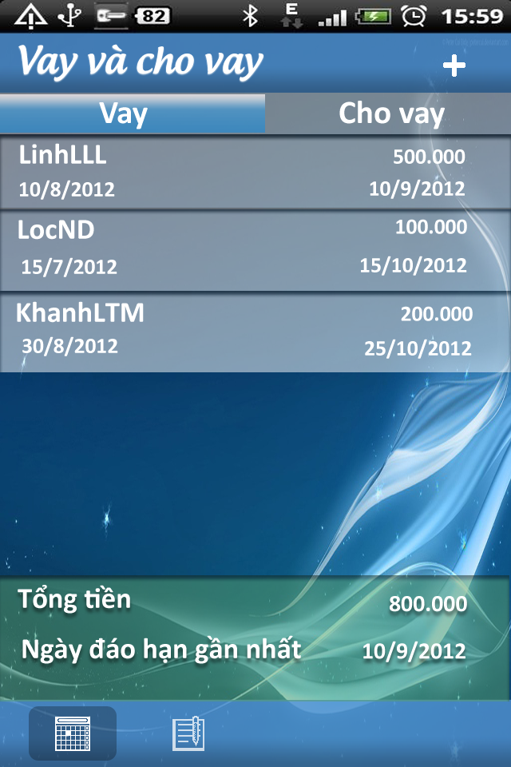
Screen:

USE CASE- View and Warning loans SPECIFICATION

Use-case No. | UC BL.4 | Use-case Version |  | 1.0
Use-case Name | View and Warning loans
Author | LinhLLL
Date | 08/09/2012 | Priority | High
Actor:
User
Summary:
User can view list of loans or loan detail.
Goal:
Allow user view loan.
Triggers
Touch “Vay” icon, thirst icon at bottom of screen.
Preconditions:
Accessed to application
Post Conditions:
<List the required post-conditions for using this case>
Main Success Scenario:

Step | Actor action | System response
1 | Touch thirst icon at bottom of screen | Display “Vay” screen includes list of information below:  - Each borrowing includes information below:  + “Tên”  + “Số điện thoại”  + “Địa chỉ”  + “Kiểu lãi”  + “Lãi suất”  + “Ngày bắt đầu”  + “Ngày đáo hạn”
2 | Touch “Cho vay” tab | - Display “Cho vay” screen includes list of lending  - Each lending includes information below:  + “Tên”  + “Số điện thoại”  + “Địa chỉ”  + “Kiểu lãi”  + “Lãi suất”  + “Ngày bắt đầu”  + “Ngày đáo hạn”

Alternative Scenario:

Step | Actor action | System response
1 | Touch thirst icon at bottom of screen | Display “Vay” screen includes list of information below:  - Each borrowing includes information below:  + “Tên”  + “Số điện thoại”  + “Địa chỉ”  + “Kiểu lãi”  + “Lãi suất”  + “Ngày bắt đầu”  + “Ngày đáo hạn”
2 | Touch “Cho vay” tab | - Display “Cho vay” screen with content “No data”

Step | Actor action | System response
1 | Touch thirst icon at bottom of screen | Display “Vay” screen with content “No data”
2 | Touch “Cho vay” tab | Display “Cho vay” screen includes list of information below:  - Each lending includes information below:  + “Tên”  + “Số điện thoại”  + “Địa chỉ”  + “Kiểu lãi”  + “Lãi suất”  + “Ngày bắt đầu”  - + “Ngày đáo hạn”

Step | Actor action | System response
1 | Touch thirst icon at bottom of screen | Display “Vay” screen with content “No data”
2 | Touch “Cho vay” tab | - Display “Cho vay” screen with content “No data”

Exceptions:
Relationships:
UC BL.1, UC BL.2, UC BL.3
Business Rules:

No | Rule Description
1 | In order to delete schedule, user must accessed application
2 | In order to delete schedule, “Schedule” screen must have at least one schedule

Screen:

Use Case 4: Report
- Use-case Diagram
Figure 4: Report use-case diagram
- Use-case Specification

Use Case 5: Warning
- Use-case Diagram
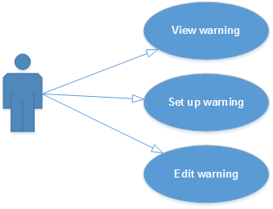
Figure 5: Warning use-case diagram
- Use-case Specification

Use Case 6: Synchronize
- Use-case Diagram
Figure 6: Synchronize use-case diagram
- Use-case Specification

Non-Functional Requirements
Non-functional requirements may exist for the following attributes. Often these requirements must be achieved at a system-wide level rather than at a unit level.
    - Performance
The main criteria for grading the performance of the system are:
- The verification process should be efficient and take less than 1 - 3 seconds to complete.
- System cans deployment at version different of android
- Content will display and done after less than 3 seconds.

Reliability
- System is capable to deal with unusually situation.
- The database has continuous back up and can be recovering if necessary.
- Not conflict with other software.

Availability
- Systems have to run 24/7
- System is capable to deal with unusually situation.
- The database has continuous back up and can be recovering if necessary

Security
To transfer data safely between client and server, encryption is used. The system shall authenticate all users with username and password. Users not authorized should not obtain access to the system.

Maintainability
The system shall have a documented source code to ease maintenance when this is needed. The system is designed based on separated modules, so it is easy to maintain or implement new version with many new functions.

Portability
The system will have to work android 2.3 or higher.

Logical Database Requirements
Will a database be used? If so, what logical requirements exist for data formats, storage capabilities, data retention, data integrity, etc.?

Other Requirements

Entity Relationship Diagram

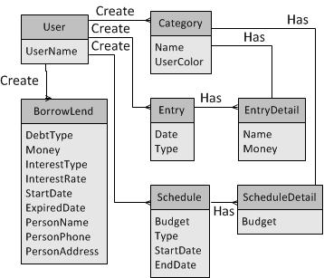

Descriptions:
_ One user can create many category, borrowing , lending, entry, schedule
_With each entry/schedule, it has many entry or schedule detail to describe detail.
_ With each entry/schedule detail, it has only one category

Change Management Process
Identify and describe the process that will be used to update the SRS, as needed, when project scope or requirements change. Who can submit changes and by what means, and how will these changes be approved.

A. Appendices.

A.1 Message
This section describes the details of messages used in project such as error messages, confirmation messages, etc.

Message Code | Message Content | Button
MSG1 | “Tổng chi phí của bạn đã vượt quá ngân sách đề ra, bạn muốn tăng thêm ngân sách không?”
MSG2 | “Thời gian này đã có lịch! Xin vui lòng chọn lại!”
MSG3 | “Bạn muốn xóa kế hoạch này không?”
MSG4 | “Xin hãy nhập dữ liệu vào các ô đang bị bỏ trống! Xin cảm ơn!”
MSG5 | “Please enter at least one field!”
MSG6 | “Bạn muốn xóa khoản vay nợ này không?”
MSG7
MSG8
MSG9
MSG10

A.2 Appendix 2

